What is Sustainability?
Sustainability is broadly defined as meeting the needs of the present generation without compromising the ability of future generations to meet their own needs. The term “sustainability,” when applied institutionally within a university, is the development of a process or management system that helps to create a vibrant campus economy and high quality of life while respecting the need to sustain natural resources and protect the environment. Sustainable programs are those that result from an institution’s commitment to environmental, social and economic health, or the “triple bottom line.” Sustainability has both individual and institutional applicability, and is usually a balancing act.
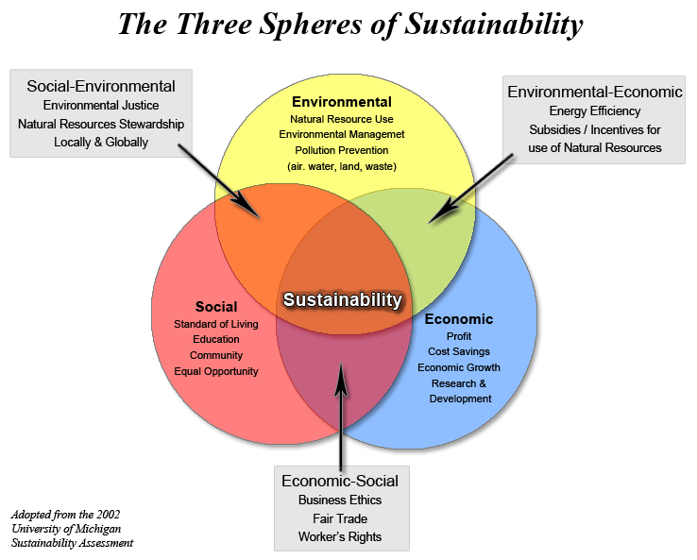
Vanderbilt University interacts with the local, national, and international communities in three major ways. As educators, Vanderbilt plays a significant role in preparing our students for future leadership throughout the world. Our students today will make the decisions of tomorrow. As a major employer and health service provider in Middle TN, we have a relationship with the community in which we operate that demands that Vanderbilt conduct its business while applying the principles of environmental and social stewardship. As a center for scholarly research, informed and creative teaching, and service to the community and society at large, we are developing and sharing best practices and cultivating new ideas concerning sustainability.
Nationally, the sustainability movement is sweeping across campuses. The National Association of College and University Business Officers (NACUBO), the Society for College and University Planning (SCUP), the Association of Physical Plant Administrators (APPA), The Chronicle of Higher Education, and the Association for the Advancement of Sustainability in Higher Education (AASHE) have embraced and endorsed campus sustainability principles and serve as a major force on the national scene.
Sources:
- World Commission on Environment and Development (WCED). Our Common Future. Oxford: Oxford University Press, 1987, p.43.
- Clough, G.W., J. Chameau, and C. Carmichael. “Sustainability and the University.” The Presidency. Winter 2006, pp. 30-40.
- Hignite, K. “Will Sustainability Take Root?” Business Officer. April 2006, pp. 12-22.

